**Project Report Format**

**1. INTRODUCTION**

1.1 Project Overview

1.2 Purpose

**2. IDEATION PHASE**

2.1 Problem Statement

2.2 Empathy Map Canvas

2.3 Brainstorming

**3. REQUIREMENT ANALYSIS**

3.1 Customer Journey map

3.2 Solution Requirement

3.3 Data Flow Diagram

3.4 Technology Stack

**4. PROJECT DESIGN**

4.1 Problem Solution Fit

4.2 Proposed Solution

4.3 Solution Architecture

**5. PROJECT PLANNING & SCHEDULING**

5.1 Project Planning

**6. FUNCTIONAL AND PERFORMANCE TESTING**

6.1 Performance Testing

**7. RESULTS**

7.1 Output Screenshots

**8. ADVANTAGES & DISADVANTAGES**

**9. CONCLUSION**

**10. FUTURE SCOPE**

**11. APPENDIX**

Source Code(if any)

Dataset Link

GitHub & Project Demo Link

**1.INTRODUCTION**

**1.1 Project Overview:**

SB Works is a web-based freelancing platform designed to connect clients and freelancers under administrative supervision. The primary objective of this project is to create a structured environment where clients can post projects, freelancers can apply and submit work, and administrators can monitor system activities and manage users.

The application supports three major roles: Admin, Client, and Freelancer. Each role has dedicated dashboards and functionalities. Clients are allowed to create and manage projects. Freelancers can browse available projects, apply to them, and submit completed work. Administrators have system-level visibility and can monitor users, projects, and applications.

The system also integrates real-time communication functionality using socket technology, allowing direct interaction between users.

The core features of the system include user registration and login with OTP verification, role-based dashboards, project creation and management, freelancer applications, work submission, review mechanisms, administrative monitoring, and real-time chat functionality.

**1.2 Purpose:**

The primary purpose of this project is to design and develop a full-stack web-based Freelance Management System that connects administrators and freelancers through a structured digital platform.The system aims to streamline project posting, application handling, and user management while ensuring secure authentication, role-based access control, and efficient data management.It also serves as a practical implementation of modern web development technologies including React, Node.js, Express.js, and MongoDB in a real-world application scenario

**Key objectives of the system include:**

* To build a complete MERN stack application integrating frontend, backend, and database components into a cohesive system.
* To ensure secure user login using JWT-based authentication and role-based access control for protected resources.
* To allow administrators to manage users and projects, and enable freelancers to apply, track, and manage their project activities.
* To design an intuitive, responsive UI that enhances usability across desktop and mobile devices.
* To securely store user credentials using password hashing and implement proper validation and error handling mechanisms.
* To follow a modular and scalable backend structure that supports future enhancements and potential real-world deployment.
* To implement complete Create, Read, Update, and Delete functionality for users, projects, and applications.
* To create a system that can later incorporate advanced features such as payment integration, real-time notifications, and enhanced analytics.

**2.IDEATION PHASE**

**2.1 Problem Statement:**

Managing freelance projects and user interactions manually or through unstructured platforms often leads to inefficiencies, miscommunication, and lack of transparency. Many existing systems do not provide secure role-based access, streamlined project management, or centralized data handling for administrators and freelancers. This creates challenges in tracking project progress, handling applications, and ensuring data security. Additionally, the absence of structured authentication mechanisms increases the risk of unauthorized access. Therefore, there is a need for a secure, scalable, and user-friendly web-based Freelance Management System that centralizes project operations, improves communication, ensures data integrity, and provides efficient role-based access control for all users.

**Problem Statement -1:**

|  |  |
| --- | --- |
| I am | A business owner/ client |
| I’m trying to | find skilled freelancers to complete my projects efficiently and within budget |
| But | I cannot easily identify reliable freelancers with verified skills and past work in one trusted platform |
| Because | many freelancers lack structured profiles, transparent reviews, and direct communication channels |
| Which makes me feel | uncertain about hiring decisions and worried about project quality |

**Problem** **Statement -2:**

|  |  |
| --- | --- |
| I am | a freelancer |
| I’m trying to | find suitable freelance projects and showcase my skills to potential clients |
| But | I cannot easily discover relevant projects or connect with genuine clients in a secure platform |
| Because | many platforms are overcrowded and do not provide fair visibility or smooth proposal and communication systems |
| Which makes me feel | overlooked, frustrated, and limited in growing my freelance career |

|  |  |  |  |  |  |
| --- | --- | --- | --- | --- | --- |
| **Problem Statement (PS)** | **I am** | **I’m trying to** | **But** | **Because** | **Which makes me feel** |
| PS-1 | A client | Hire skilled freelancers for my projects within budget and timeline | It is hard to identify reliable freelancers and compare their skills and experience | Freelancer profiles, reviews, and communication are scattered or unclear across platforms | Uncertain and worried about project success |
| PS-2 | A freelancer | Find suitable projects and showcase my skills to genuine clients | It is difficult to discover relevant projects and get selected fairly | Platforms are overcrowded and lack transparent bidding and direct communication systems | Overlooked and frustrated |

**2.2 Empathy Map:**

**User: - Charan** (A working professional as a freelancer.)

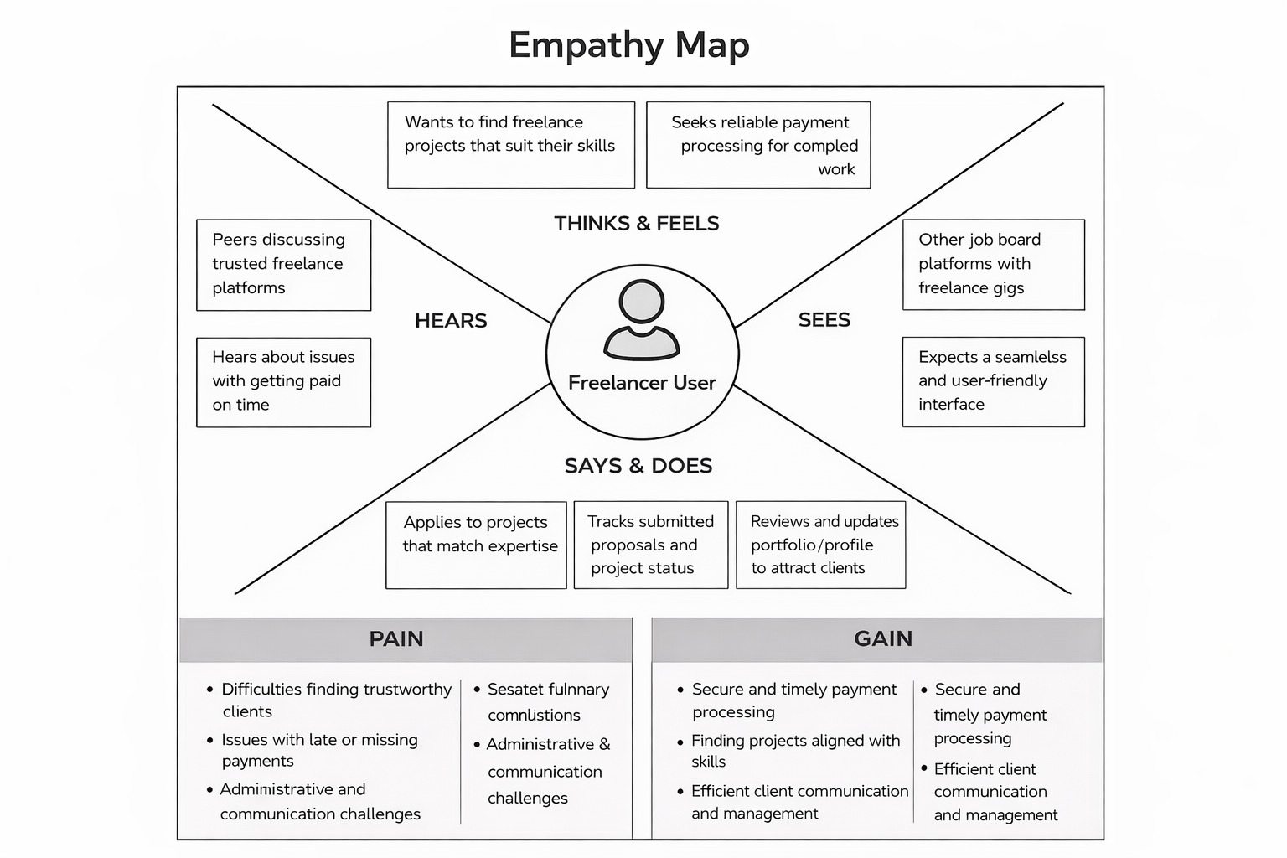

**2.2 Brainstorm & Idea Prioritization:-**

**Step-1: Team Gathering, Collaboration and Select the Problem Statement**

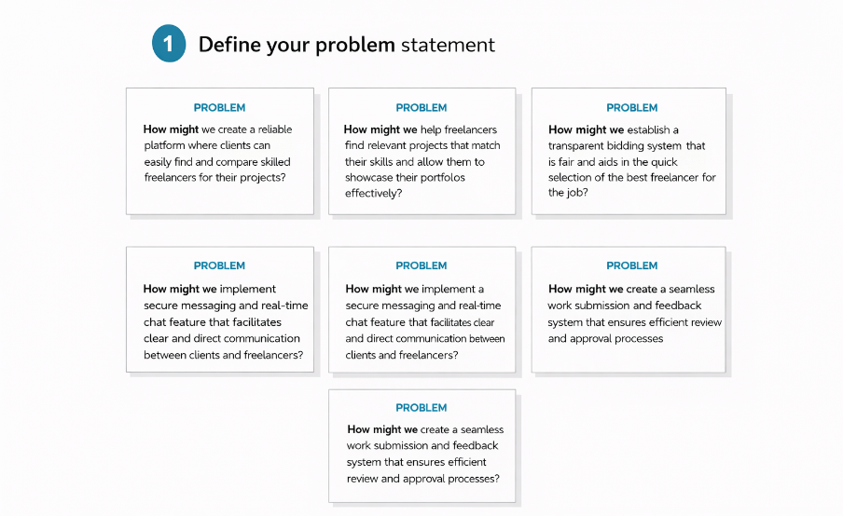

**Step-2: Brainstorm, Idea Listing and Grouping**

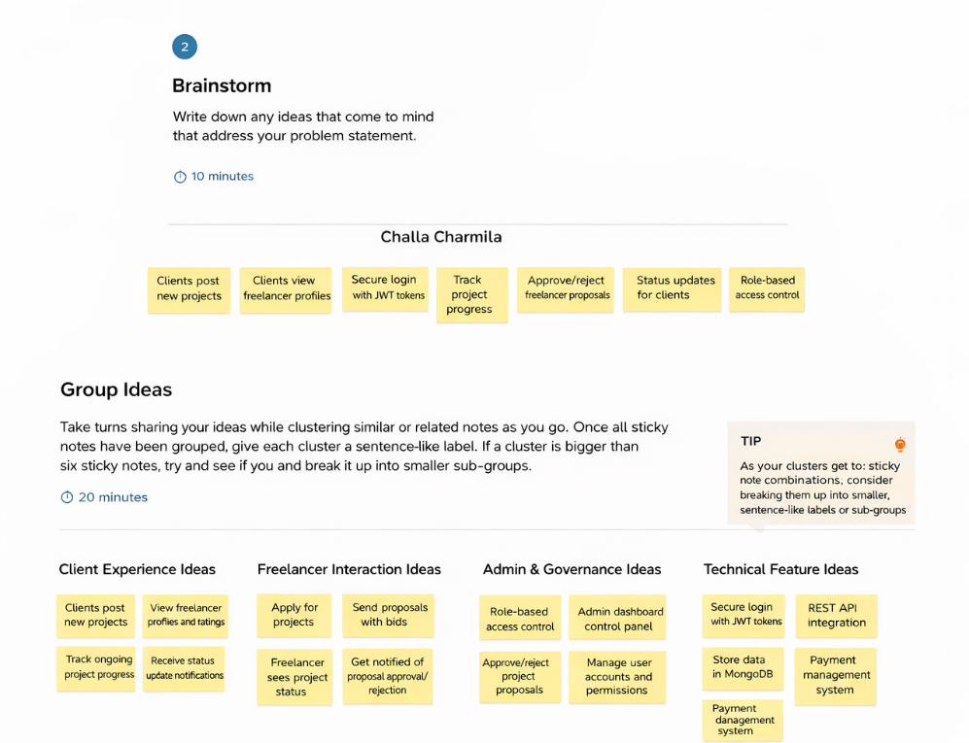

**Step-3: Idea Prioritization**

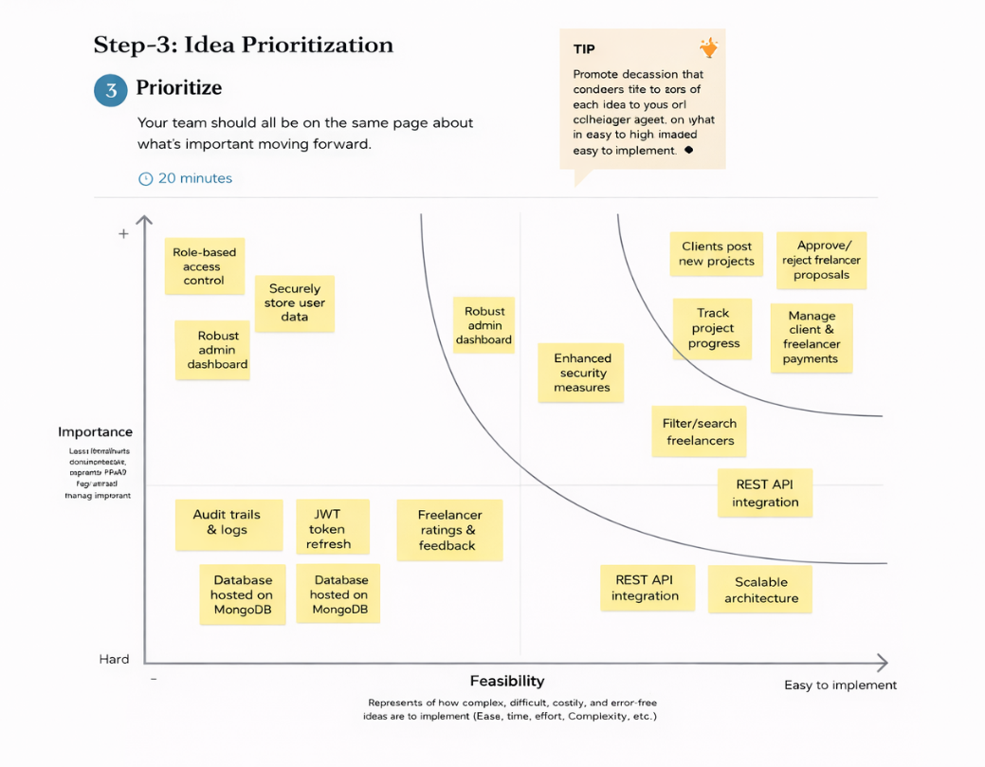

**3. REQUIREMENT ANALYSIS**

**3.1 Journey map: -**

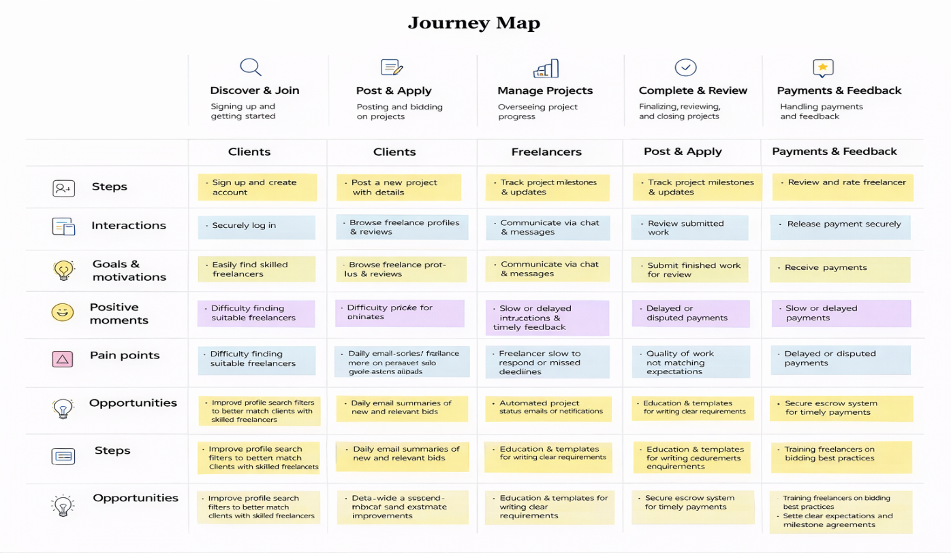

**3.2 Solution Requirement**

**Functional Requirements:**

Following are the functional requirements of the proposed solution.

|  |  |  |
| --- | --- | --- |
| **FR No.** | **Functional Requirement (Epic)** | **Sub Requirement (Story / Sub-Task)** |
| FR-1 | User Registration | Registration through form Registration via email Role selection (Client/ Freelancer) |
| FR-2 | User Authentication | Login using Email & Password Logout Password reset |
| FR-3 | Freelancer Profile Management | Create freelancer profile Add skills & bio Upload portfolio |
| FR-4 | Project Posting | Client creates project Add description, budget, deadline Edit/ delete project |
| FR-5 | Product Browsing & Search | View all projects Filter by skills/ budget View project details |
| FR-6 | Bidding/ Applications | Freelancer applies to project Submit proposal & bid View application status |
| FR-7 | Freelancer Selection | Client reviews applications Accept/ reject freelancer |
| FR-8 | Chat & Communication | Real-time chat client and freelancer interaction Message notifications |
| FR-9 | Project Submission | Freelancer submits work Client reviews submission |
| FR-10 | Reviews & Ratings | Client rates freelancer View feedback |
| FR- 11 | Admin Management | View users & projects Monitor platform activity |

**Non-functional Requirements:**

Following are the non-functional requirements of the proposed solution.

|  |  |  |
| --- | --- | --- |
| **FR No.** | **Non-Functional Requirement** | **Description** |
| NFR-1 | **Usability** | The platform should provide an intuitive and user-friendly interface for clients and freelancers with easy navigation and clear workflows. |
| NFR-2 | **Security** | User data, passwords, and communications must be securely stored and transmitted using encryption and authentication mechanisms. |
| NFR-3 | **Reliability** | The system should ensure consistent operation with minimal failures and accurate handling of projects, applications, and messages. |
| NFR-4 | **Performance** | The platform should load pages and respond to user actions quickly, even with multiple concurrent users. |
| NFR-5 | **Availability** | The system should be accessible 24/7 with minimal downtime for users across different locations |
| NFR-6 | **Scalability** | The architecture should support growth in users, projects, and data without performance degradation. |

**3.3 Data Flow Diagram: -**

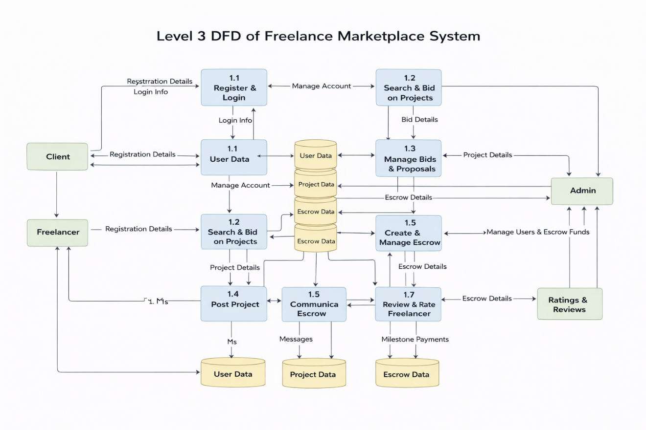

**3.4 Technology Stack: -**

**Technical Architecture: -**

The Freelance finding application follows a 3-Tier Client–Server Architecture:

• **Presentation Layer (Frontend):** The frontend is developed using React.js to provide a responsive and user-friendly interface for Clients and Freelancers. It handles user interactions, dashboards, forms, and communicates securely with backend APIs.

• **Application Layer (Backend):** The backend is built with Node.js and Express.js to manage business logic, authentication, and project workflows. It processes API requests, handles role-based access control, and ensures secure data transactions.

• **Data Layer (Database):** MongoDB is used to store user profiles, projects, bids, payments, and reviews in structured collections. It ensures data integrity, scalability, and secure storage with proper indexing and validation.

The frontend uses React to enable dynamic rendering, improved performance, seamless navigation, state management, user interactions, secure communication with backend APIs.

**Table-1: Components & Technologies:**

|  |  |  |  |
| --- | --- | --- | --- |
| **S. No** | **Component** | **Description** | **Technology** |
|  | User Interface | Web interface for clients and freelancers to register, browse projects, apply, chat, and manage work | HTML, CSS, JavaScript, React.js, Bootstrap |
|  | Application Logic-1 | User authentication, registration, role management, profile handling | Node.js, Express.js |
|  | Application Logic-2 | Project management, bidding system, freelancer selection | Express.js, Node.js |
|  | Application Logic-3 | Real-time chat and notifications between client and freelancer | Socket.IO |
|  | Database | Stores users, freelancers, projects, applications, chats, reviews | MongoDB, Mongoose |
|  | Cloud Database | Database hosting in cloud | MongoDB Atlas |
|  | File Storage | Storage for portfolio files, project attachments, submission files | Cloudinary / Local Storage |
|  | External API-1 | |  | | --- | |  |  |  | | --- | | Email notifications for registration, project updates, and messages | | Nodemailer/ SMTP |
|  | External API-2 | Authentication and secure password handling | JWT/ bcrypt |
|  | Infrastructure (Server / Cloud) | Backend server deployment and hosting of full-stack MERN application | Node.js Server, Render / AWS / Vercel |

**Table-2: Application Characteristics:**

| **S. No** | **Characteristics** | **Description** | **Technology** |
| --- | --- | --- | --- |
|  | Open-Source Frameworks | Frameworks used to develop frontend and backend | React.js, Node.js, Express.js, Bootstrap |
|  | Security Implementations | Secure authentication, password encryption, protected APIs | JWT Authentication, bcrypt hashing, HTTPS |
|  | Scalable Architecture | MERN 3-tier architecture separating UI, server, and database | React + Node/Express + MongoDB |
|  | Availability | |  | | --- | |  |  |  | | --- | | Cloud hosting ensures 24/7 platform access | | Render / Vercel / MongoDB Atlas |
|  | Performance | Efficient API communication and optimized frontend rendering | Axios, REST APIs, React Virtual DOM |

**4. PROJECT DESIGN**

**4.1 Problem Solution Fit : -**

The project addresses the inefficiencies and lack of transparency in managing freelance projects through unstructured or manual systems. Clients often struggle to find suitable freelancers, while freelancers face difficulty in discovering reliable projects and secure payment mechanisms.

The proposed solution directly fits these problems by providing a centralized, role-based web platform that streamlines project posting, bidding, communication, and management. By integrating secure authentication, structured workflows, and real-time status tracking, the system ensures clarity, accountability, and efficiency for both clients and freelancers, effectively bridging the gap between demand and skilled talent.

. 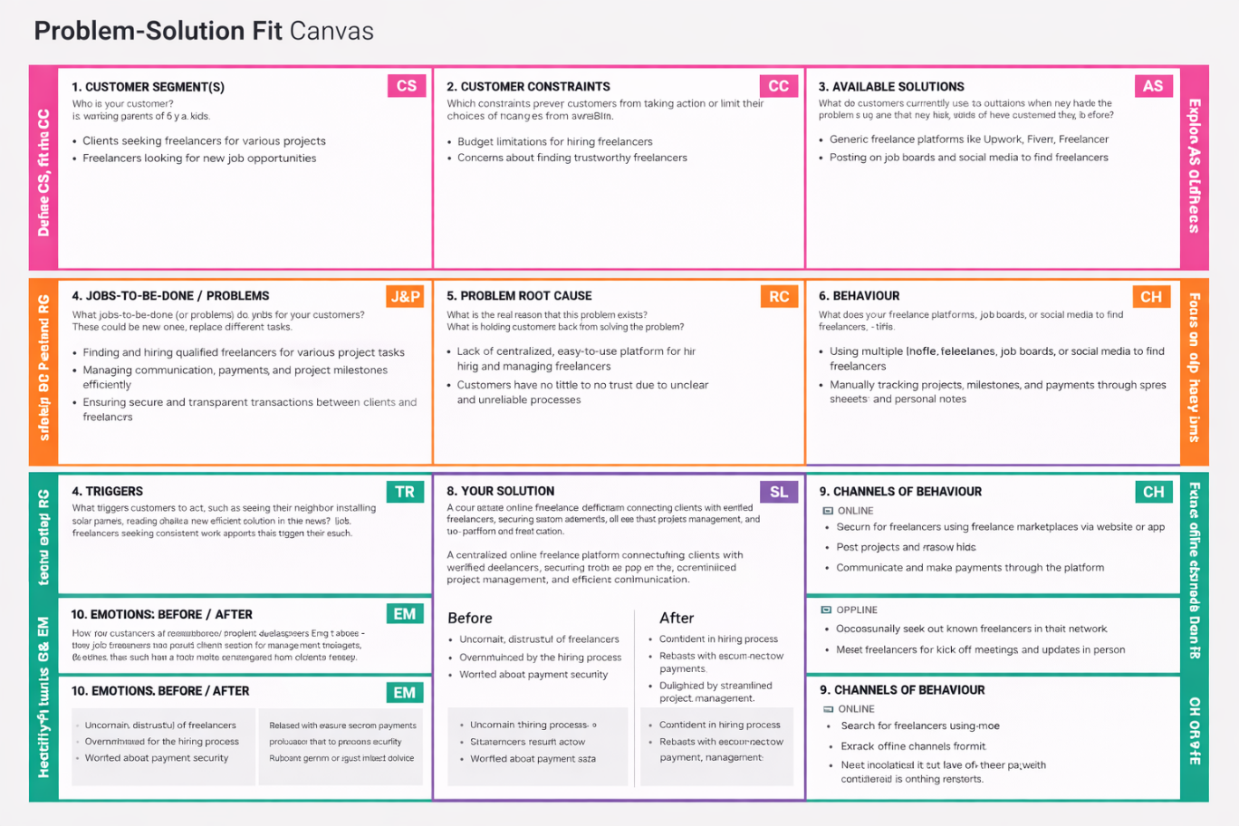

**4.2 Proposed Solution : -**

|  |  |  |
| --- | --- | --- |
| **S.No** | **Parameter** | **Description** |
| 1 | **Problem Statement (Problem to be solved)** | Clients face difficulty in finding reliable and skilled freelancers, while freelancers struggle to discover relevant projects and showcase their capabilities in a trusted and transparent environment. |
| 2 | **Idea / Solution Description** | SB Works (FreelanceFinder) is a MERN-based online freelancing platform that connects clients and freelancers in a unified system. Clients can post projects, review freelancer profiles, and hire suitable candidates, while freelancers can browse projects, submit proposals, communicate via real-time chat, and deliver work through the platform. |
| 3 | **Novelty / Uniqueness** | The platform integrates project discovery, freelancer verification, bidding, communication, and submission in a single streamlined workflow. It emphasizes transparency through structured profiles, project tracking, and direct client-freelancer interaction within one system. |
| 4 | **Social Impact / Customer Satisfaction** | The solution empowers freelancers by providing equal access to opportunities and helps clients efficiently hire skilled professionals. It promotes digital employment, remote collaboration, and economic growth while improving hiring trust and satisfaction. |
| 5 | **Business Model (Revenue Model)** | The platform can generate revenue through service fees or commission on successful projects, premium freelancer memberships for enhanced visibility, and featured project listings for clients. |
| 6 | **Scalability of the Solution** | Built on MERN stack with cloud-hosted database and modular architecture, the platform can scale to support increasing users, projects, and real-time interactions without performance degradation. |

**4.3 Solution Architecture : -**

The solution architecture follows a layered full-stack design to ensure scalability, security, and maintainability of the Freelance Management System. It is structured into three main layers: Presentation Layer, Application Layer, and Data Layer.

The Presentation Layer (Frontend) is developed using React and follows a Single Page Application architecture. It provides separate dashboards for Clients, Freelancers, and Admin, enabling dynamic content rendering and smooth navigation. This layer handles user interactions, form validations, state management, and secure communication with backend APIs.

The Application Layer (Backend) is built using Node.js and Express.js. It manages business logic, authentication using JWT, role-based authorization, project workflows, and RESTful API endpoints. Middleware ensures request validation, error handling, and secure access control.

The Data Layer (Database) uses MongoDB to store users, projects, bids, payments, and reviews. Proper indexing, schema validation, and secure storage mechanisms ensure data integrity, consistency, and efficient retrieval across the system.

Secure JWT-based authentication ensures protected access, while modular architecture enables scalability, maintainability, and future enhancements.

.

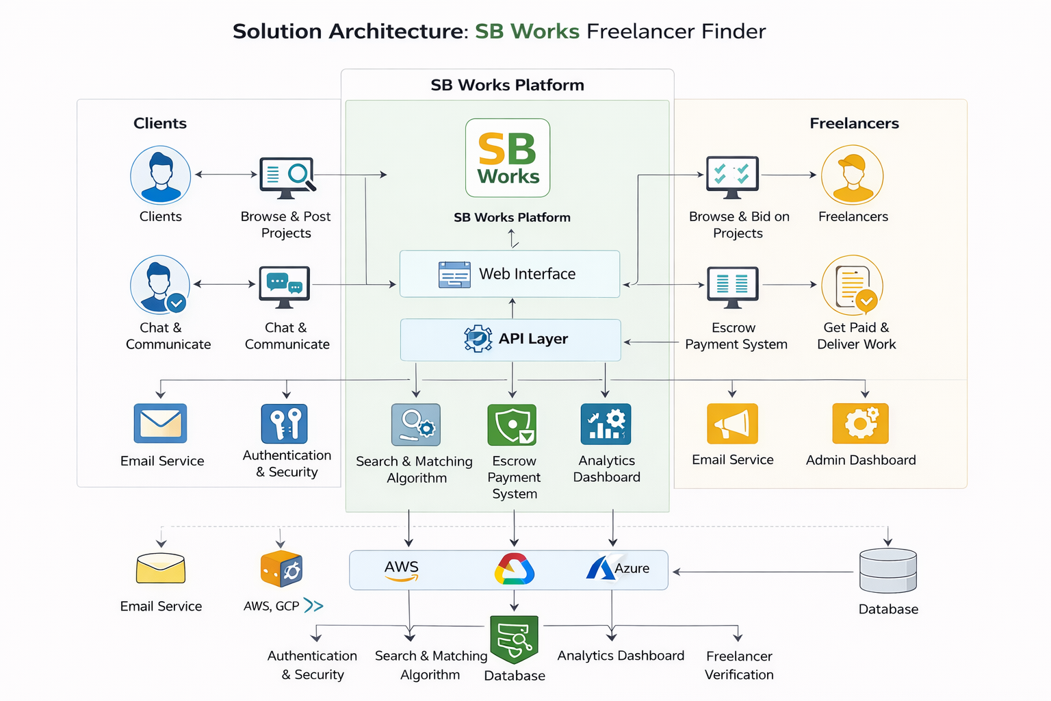

**5. PROJECT PLANNING & SCHEDULING**

**5.1 Project Planning : -**

**Product Backlog & Sprint Planning (Freelance Finder)**

|  |  |  |  |  |  |
| --- | --- | --- | --- | --- | --- |
| **Sprint** | **Functional Requirement (Epic)** | **User Story No** | **User Story / Task** | **Story Points** | **Priority** |
| Sprint-1 | Registration | USN-1 | As a user, I can register using email and password | 2 | High |
| Sprint-1 | Registration | USN-2 | As a user, I can select role (client/freelancer) during registration | 2 | High |
| Sprint-1 | Login | USN-3 | As a user, I can log in using email & password | 1 | High |
| Sprint-1 | Profile | USN-4 | As a freelancer, I can create and update my profile | 3 | High |
| **Sprint-1 Total** |  |  |  | 8 |  |
| **Sprint-2** | **Functional Requirement** | **User Story No** | **User Story** | **Story Points** | **Priority** |
| Sprint-2 | Project Posting | USN-5 | As a client, I can post a new project with details | 3 | High |
| Sprint-2 | Project Browsing | USN-6 | As a freelancer, I can browse available projects | 2 | High |
| Sprint-2 | Bidding | USN-7 | As a freelancer, I can apply to a project with proposal | 3 | High |
| **Sprint-2 Total** |  |  |  | **8** |  |
| **Sprint-3** | **Functional Requirement** | **User Story No** | **User Story** | **Story Points** | **Priority** |
| Sprint-3 | Freelancer Selection | USN-8 | As a client, I can review applications and select freelancer | 3 | High |
| Sprint-3 | Chat | USN-9 | As a client/freelancer, I can send messages in chat | 5 | High |
| **Sprint-3 Total** |  |  |  | **8** |  |
| **Sprint-4** | **Functional Requirement** | **User Story No** | **User Story** | **Story Points** | **Priority** |
| Sprint-4 | Submission | USN-10 | As a freelancer, I can submit completed work | 2 | Medium |
| Sprint-4 | Review | USN-11 | As a client, I can review and approve submission | 2 | Medium |
| Sprint-4 | Admin | USN-12 | As an admin, I can view users and project | 4 | Medium |
| **Sprint-4 Total** |  |  |  | **9** |  |

**Sprint Tracker (Velocity Table)**

|  |  |  |  |  |  |  |
| --- | --- | --- | --- | --- | --- | --- |
| **Sprint** | **Total Story Points** | **Duration** | **Start** | **End (Planned)** | **Completed** | **Actual** |
| Sprint-1 | 8 | 6 days | Day 1 | Day 6 | 8 | Day 6 |
| Sprint-2 | 8 | 6 days | Day 7 | Day 12 | 8 | Day 12 |
| Sprint-3 | 8 | 6 days | Day 13 | Day 18 | 8 | Day 18 |
| Sprint-4 | 9 | 6 days | Day 19 | Day 24 | 9 | Day 24 |

**Velocity Calculation**

From sprint table:

* Sprint-1 = 8 points
* Sprint-2 = 8 points
* Sprint-3 = 8 points
* Sprint-4 = 9 points

Total completed story points = 33

Number of sprints = 4

**Average Velocity = 33 / 4 = 8.25 ≈ 8 points per sprint**

If sprint duration = 6 days:

**Velocity per day = 8 / 6 ≈ 1.33 points/day**

The team completed a total of 33 story points across 4 sprints.  
The average team velocity is approximately 8 story points per sprint.  
With a sprint duration of 6 days, the average velocity is 1.33 story points per day.

**Burndown Chart :**

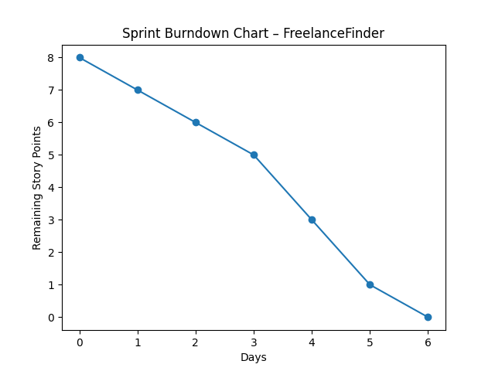

**6. FUNCTIONAL AND PERFORMANCE TESTING**

**6.1 Functional Testing**

**Test Scenarios & Results**

|  |  |  |  |  |  |
| --- | --- | --- | --- | --- | --- |
| **Test Case ID** | **Scenario (What to test)** | **Test Steps (How to test)** | **Expected Result** | **Actual Result** | **Pass/Fail** |
| FT-01 | User Registration Validation | Enter valid and invalid email/password during registration | Valid inputs accepted, errors for invalid inputs | System validates inputs correctly | Pass |
| FT-02 | User Login Authentication | Enter correct & incorrect login credentials | Login success for valid; error for invalid | Authentication works correctly | Pass |
| FT-03 | Project Posting | Client fills project form and submits | Project created and visible in listings | Project created successfully | Pass |
| FT-04 | Project Browsing | Freelancer views available projects | Projects list loads correctly | Projects displayed correctly | Pass |
| FT-05 | Bid Submission | Freelancer submits proposal on project | Freelancer submits proposal on project | Bid saved successfully | Pass |
| FT-06 | Freelancer Selection | Client selects freelancer from applications | Freelancer assigned to project | Selection works correctly | Pass |
| FT-07 | Chat Functionality | Send messages between client and freelancer | Messages delivered in real-time | Chat works correctly | Pass |
| FT-08 | Project Submission | Freelancer uploads submission | Submission stored and visible to client | Submission successful | Pass |
| FT-09 | Review & Rating | Client rates freelancer after completion | Client rates freelancer after completion | Rating stored correctly | Pass |

**Performance Testing**

|  |  |  |  |  |  |
| --- | --- | --- | --- | --- | --- |
| **Test Case ID** | **Scenario** | **Test Steps** | **Expected Result** | **Actual Result** | **Pass/Fail** |
| PT-01 | Page Load Response Time | Open project list/dashboard | Page loads under 3 seconds | Loads within limit | Pass |
| PT-02 | Concurrent Users | Multiple users browse/apply simultaneously | System handles without crash | Stable performance observed | Pass |
| PT-03 | Chat Performance | Send multiple rapid messages | Messages delivered instantly | No delay observed | Pass |

**7. RESULTS**

**7.1 Output Screenshots**

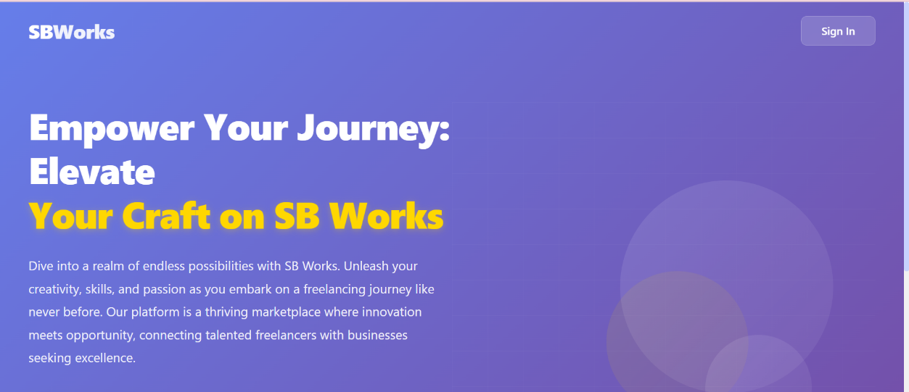

**Fig :** Public Home Page

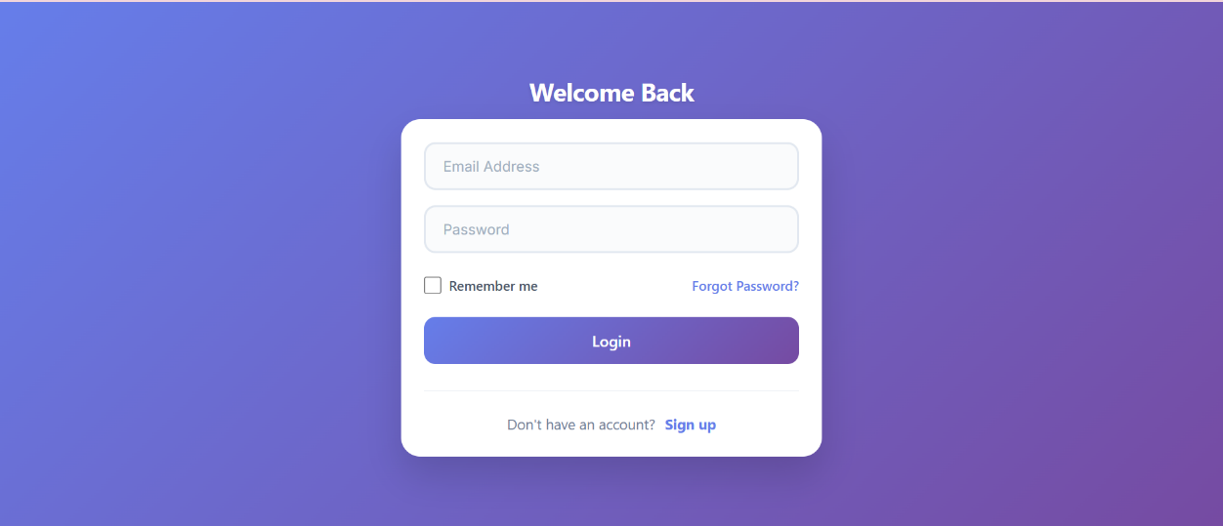

**Fig :** Login page

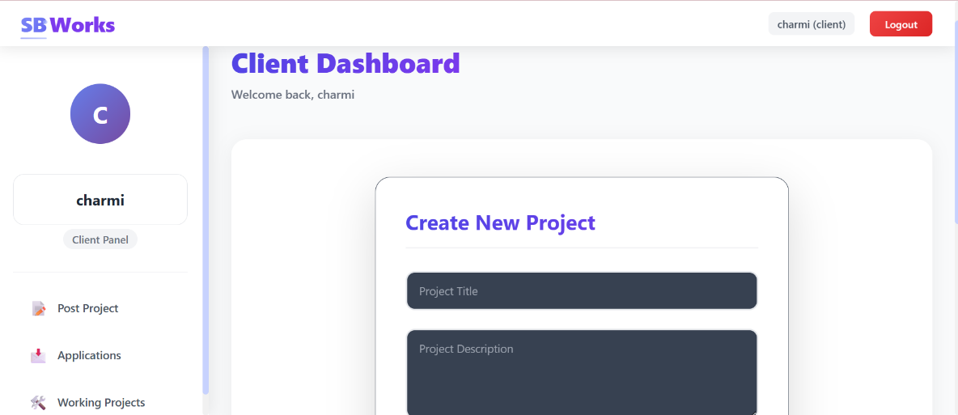

**Fig :** Client Dashboard

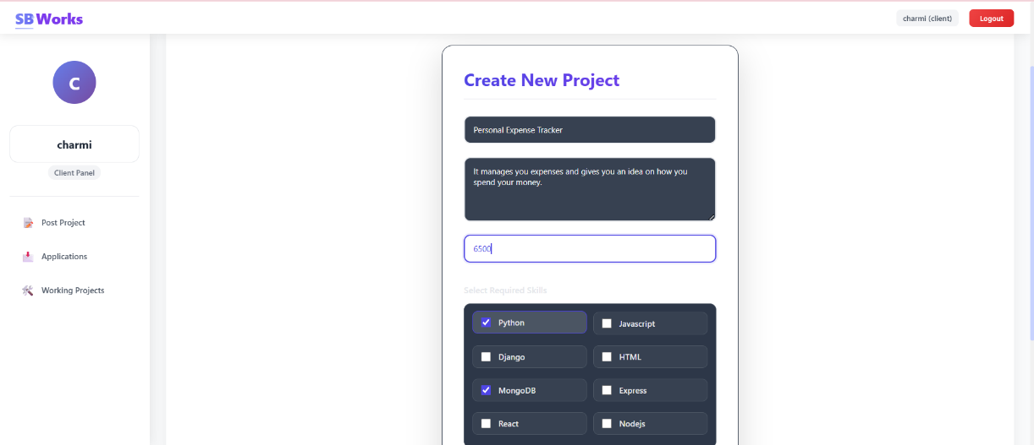

**Fig :** Uploading of the project in the client

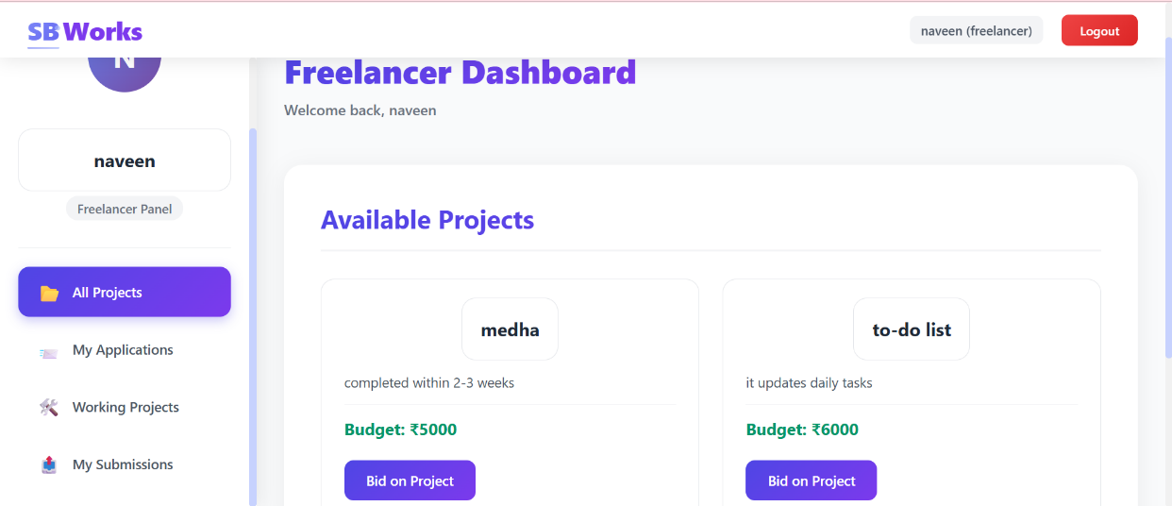

**Fig :** Freelancers shown all the porjects from clients

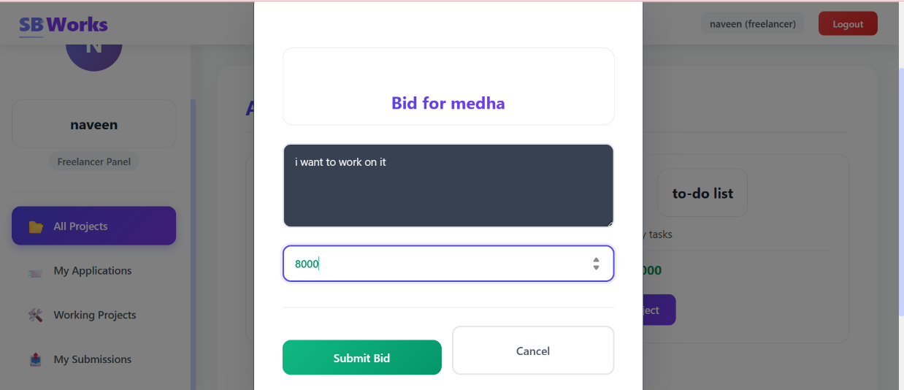

**Fig :** Freelancer bidding on the project

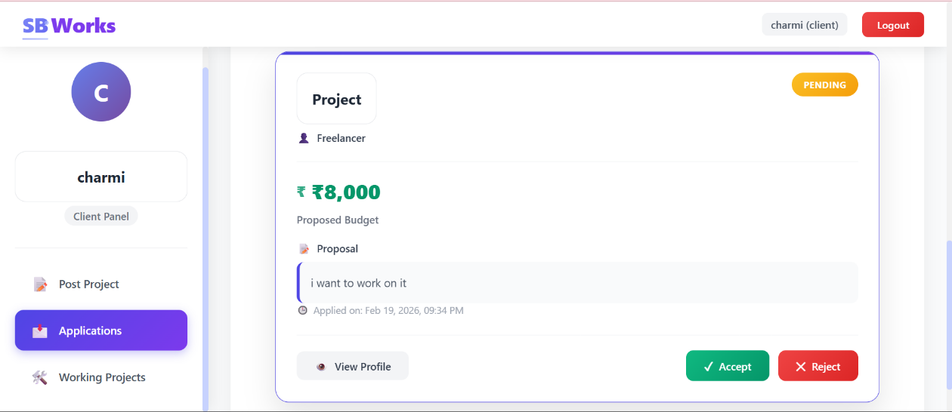

**Fig :** Client getting the bid from the freelance

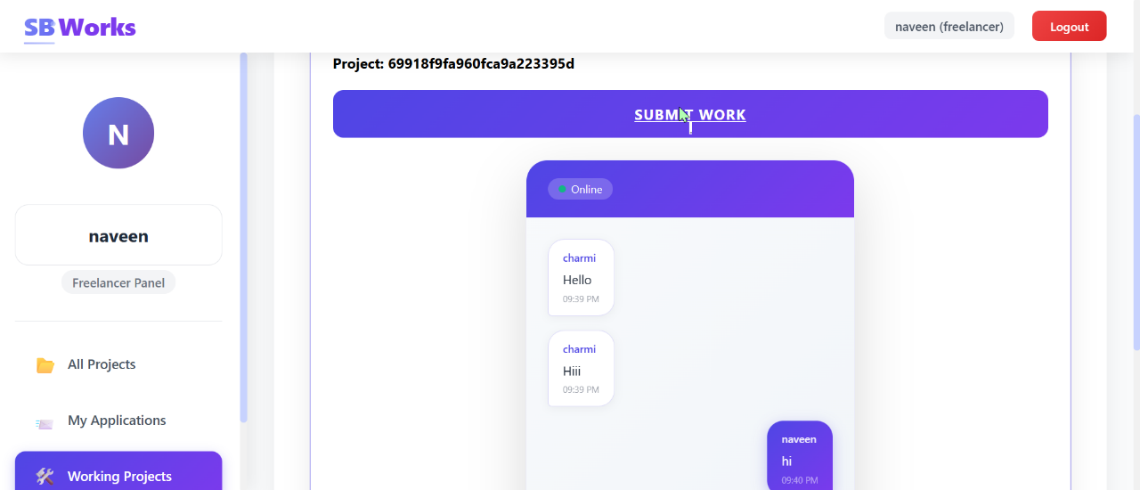

**Fig :** Conversation build up between the client and freelancer

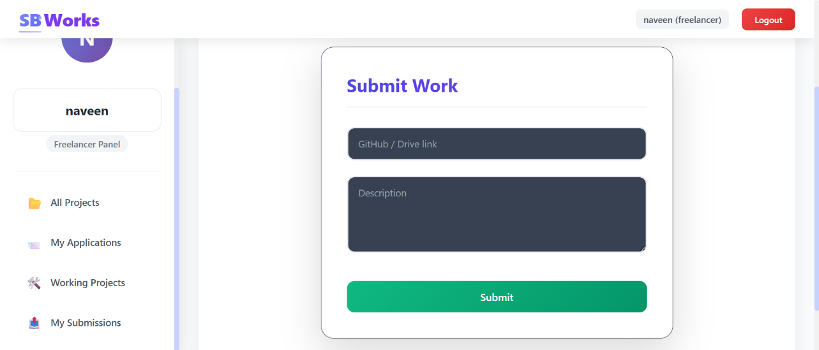

**Fig :** Freelancer submitting the work

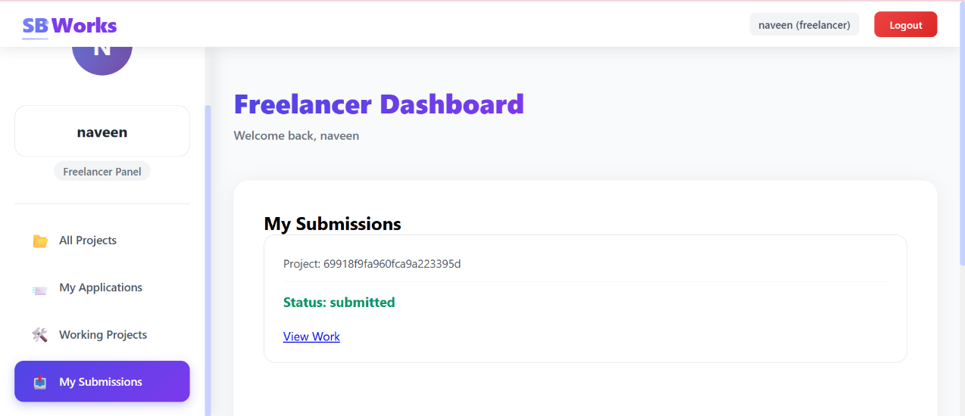

**Fig :** Freelancer submitting the project

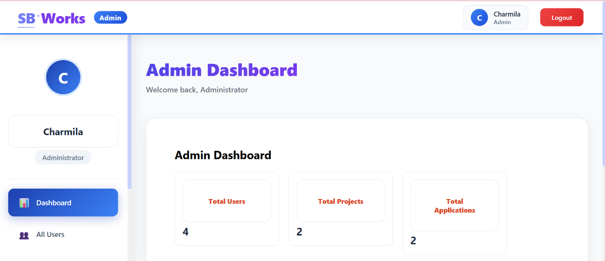

**Fig :** Admin dashboard

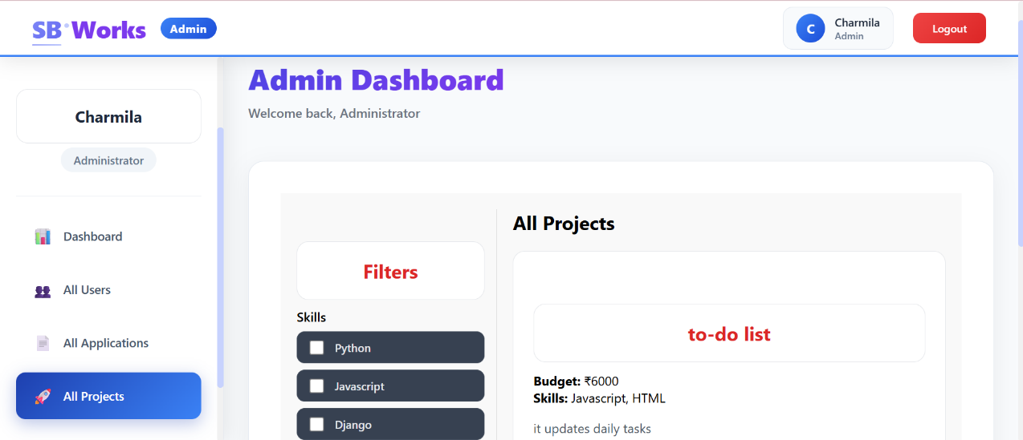

**Fig :** All the projects viewed by the admin

**8. ADVANTAGES & DISADVANTAGES**

**Advantages of the Project**

1. **Full-Stack Implementation**  
   The project demonstrates complete frontend and backend integration using the MERN stack, providing practical experience in building and deploying real-world web applications.
2. **Role-Based Access Control**Separate roles for Client, Freelancer, and Admin ensure secure access control and proper authorization for sensitive operations.
3. **Scalable Architecture**  
   The modular backend structure and layered architecture make the system easy to maintain, update, and extend with new features.
4. **Secure Authentication**  
   JWT-based authentication and password hashing enhance data protection and prevent unauthorized access.
5. **Responsive User Interface**  
   The React-based SPA provides dynamic rendering, smooth navigation, and improved user experience across devices.
6. **Efficient Project Management**  
   The system centralizes project posting, bidding, and tracking, improving workflow transparency and efficiency.
7. **Database Flexibility**  
   MongoDB’s NoSQL structure allows flexible data modeling and easy scaling as the number of users and projects grows.
8. **Clear Separation of Concerns**  
   Frontend, backend, and database layers are logically separated, improving maintainability and code readability.

**Disadvantages of the Project**

1. **Limited Real-Time Features**  
   The system does not currently support real-time notifications or live messaging between users.
2. **No Integrated Payment Gateway**  
   Payment processing is not fully automated with a secure third-party payment integration.
3. **Basic Role Management**  
   Only predefined roles are supported, without granular permission customization.
4. **Token Expiration Handling**The absence of refresh token mechanisms may interrupt user sessions after token expiry.
5. **Limited Advanced Search**  
   The platform lacks advanced filtering and recommendation algorithms for better project–freelancer matching.
6. **Initial Learning Curve**  
   Understanding and managing the MERN stack may be challenging for beginners.
7. **Scalability Constraints**  
   Without advanced caching and load balancing, performance may reduce under very high traffic conditions.

**9. CONCLUSION**

The Freelance Management System project successfully demonstrates the design and development of a secure, scalable, and user-centric full-stack web application using the MERN stack (MongoDB, Express.js, React, and Node.js). The primary objective of the project was to create a centralized digital platform that efficiently connects clients and freelancers while ensuring transparency, structured workflows, and secure data management. Through systematic planning, design, and implementation, the project achieves its goal of streamlining freelance project operations in a practical and technically sound manner.

The frontend, built with React, provides a responsive and dynamic Single Page Application that enhances user experience through smooth navigation and real-time interface updates. Separate dashboards for clients, freelancers, and administrators ensure clarity of responsibilities and efficient task management. The backend, developed using Node.js and Express.js, effectively handles business logic, API communication, authentication, and authorization. JWT-based authentication and password hashing mechanisms strengthen system security and protect sensitive user data.

The use of MongoDB as the database enables flexible data modeling and scalable storage for users, projects, bids, and related records. Proper validation and structured schema design ensure data integrity and reliability. The modular architecture followed in the backend promotes maintainability, making it easier to enhance features or fix issues in the future. By separating concerns into presentation, application, and data layers, the system maintains a clean and organized structure.

From a functional perspective, the platform provides essential features such as user registration, secure login, project posting, application management, role-based access control, and administrative monitoring. These features collectively create a controlled and efficient environment for freelance collaboration. The project also highlights the importance of structured testing, documentation, and deployment planning in building reliable software systems.

While the current implementation meets core requirements, certain limitations such as the absence of real-time notifications, advanced recommendation systems, and integrated payment gateways present opportunities for further development. These enhancements can significantly improve user engagement and system scalability. The project therefore not only serves as a working application but also as a foundation for future innovation and expansion.

Overall, the Freelance Management System reflects a comprehensive understanding of modern web development principles, secure authentication practices, database management, and layered architecture design. It demonstrates the practical application of theoretical knowledge into a real-world solution. The system is capable of handling essential freelance workflow processes efficiently and securely, making it a strong base for further enhancements and potential commercial deployment.

**10. FUTURE SCOPE**

The Freelance Finding project has strong potential for expansion in terms of scalability, security, and feature enhancement. With additional integrations and advanced functionalities, the system can evolve into a complete enterprise-level freelance platform. Future improvements can significantly enhance user experience, automation, and overall system performance.

**1. Real-Time Communication System**

Integrate live chat and instant notifications using WebSocket technology for seamless interaction.This will enable faster decision-making between clients and freelancers.  
It will significantly enhance user engagement and collaboration efficiency.

**2. Advanced Payment Gateway Integration**

Implement secure payment gateways with escrow and milestone-based release mechanisms.  
This will ensure secure transactions and build trust between users. Automated payment tracking will improve financial transparency and accountability.

**3. AI-Based Recommendation System**

Develop intelligent matching algorithms to recommend projects to freelancers and suitable freelancers to clients. Machine learning models can analyze skills, ratings, and past activity.  
This will improve project success rates and reduce search time.

**4. Mobile Application Development**

Create a mobile application using cross-platform frameworks for wider accessibility.  
Push notifications can improve user responsiveness and engagement. This will expand the platform’s reach and usability.

**5. Advanced Analytics Dashboard**

Introduce visual reports and performance analytics for users and administrators.  
Data insights can help track project progress, earnings, and productivity. This will support informed decision-making and platform optimization.

**6. Custom Role and Permission Management**

Allow dynamic creation of roles with granular permission settings. This will make the system adaptable for larger organizations. It will enhance flexibility and enterprise-level usability.

**7. Cloud Scalability and DevOps Enhancement**

Implement containerization and automated CI/CD pipelines for smoother deployment.  
Load balancing and caching mechanisms can improve performance under heavy traffic.  
This will ensure high availability, scalability, and reliability in production environments.

**11. APPENDIX**

My Project Source code Files are available at :

https://drive.google.com/drive/folders/1kcJ-GexOT2mXwTMGL0MzXz7VeimVtBjo?usp=sharing

My project Demo Video link is available at :

<https://drive.google.com/file/d/1Z43JVtqQgs9Gz9h719uokWyDsm-v6V2z/view?usp=sharing>

Github Resopitory Link :

https://github.com/ansar-ali11/SmartBridge